Purpose

The purpose of this app is to match the ages of different end-users with that of famous people who died with ranging ages from 20 to 100 years only, the application also prints some information about the famous person who such as what they are famously known for while also printing a picture of the famous person.

Design Considerations

Intuitive design, the application is easy to follow from top to bottom the applications input buttons are clear and coloured for users to recognise the application button icons. Content prioritisation, only the necessary interface elements are included in the application for simple use and essential content and functionalities are used such as the feedback information that is displayed about the famous person informing the user. Legible text content, the font used is clear and simple for the user to read for instance referring to screen print below the name of the famous person is displayed clear in a text size that any end-user would be able to read. Interface elements are clear and visible to read with easy hand-eye coordination while using the application and is not cluttered with display or print elements. Hand position controls are set to fit Android display screens the end-user will be able reach buttons without pressing the wrong buttons. The images used in the application are intent on depicting the famous person with clarity through visuals emphasizing the famous person and not only displaying the face of the person for instance, in the below screen print showing Queen Elizabeth, it shows her holding ‘The Crowning Jewels’ and clearly anybody viewing the image would think that the person they are viewing may have attained their fame by being of royal descent.

***QUEEN ELIZABETH II***

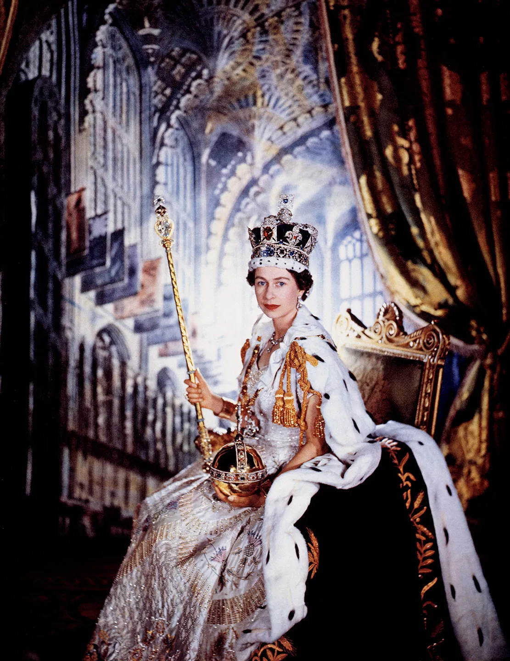

*A Queen of the United Kingdom and other Commonwealth realms and famously known her long reign over the British Empire.*  ***She died at the age of 95 years***

# Enter age

screen print